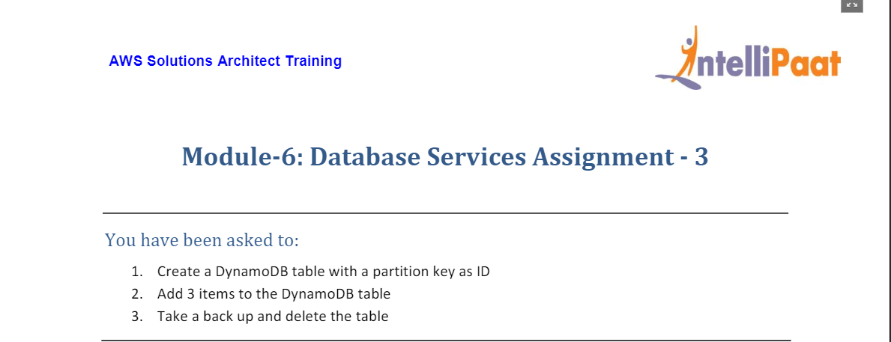

1. From Console Home go to Database

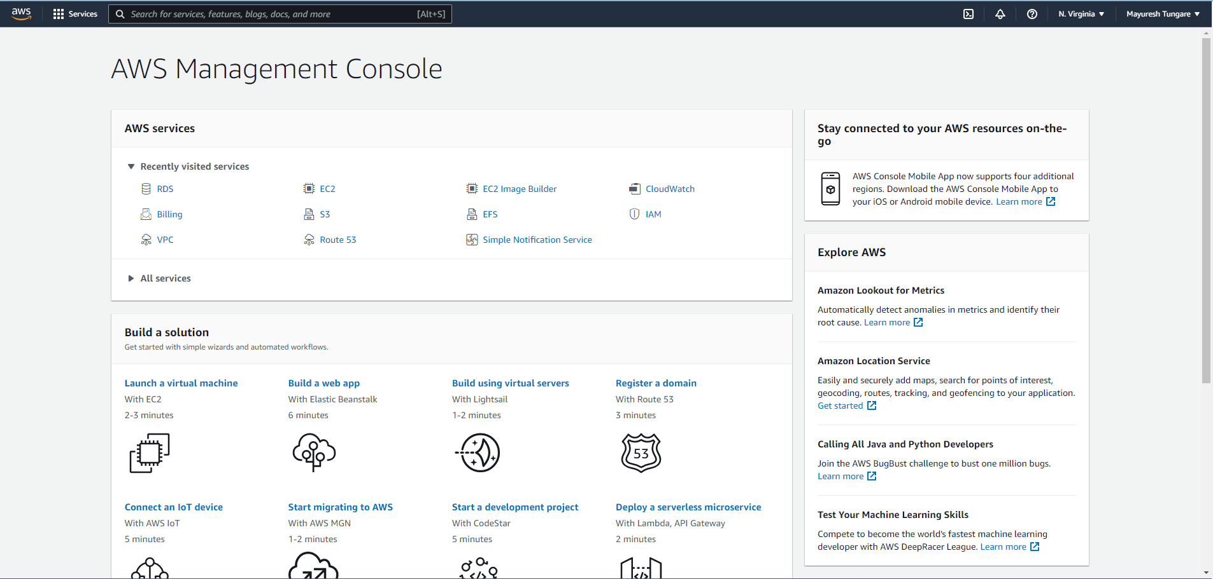

1. From Database, choose DynamoDB option.

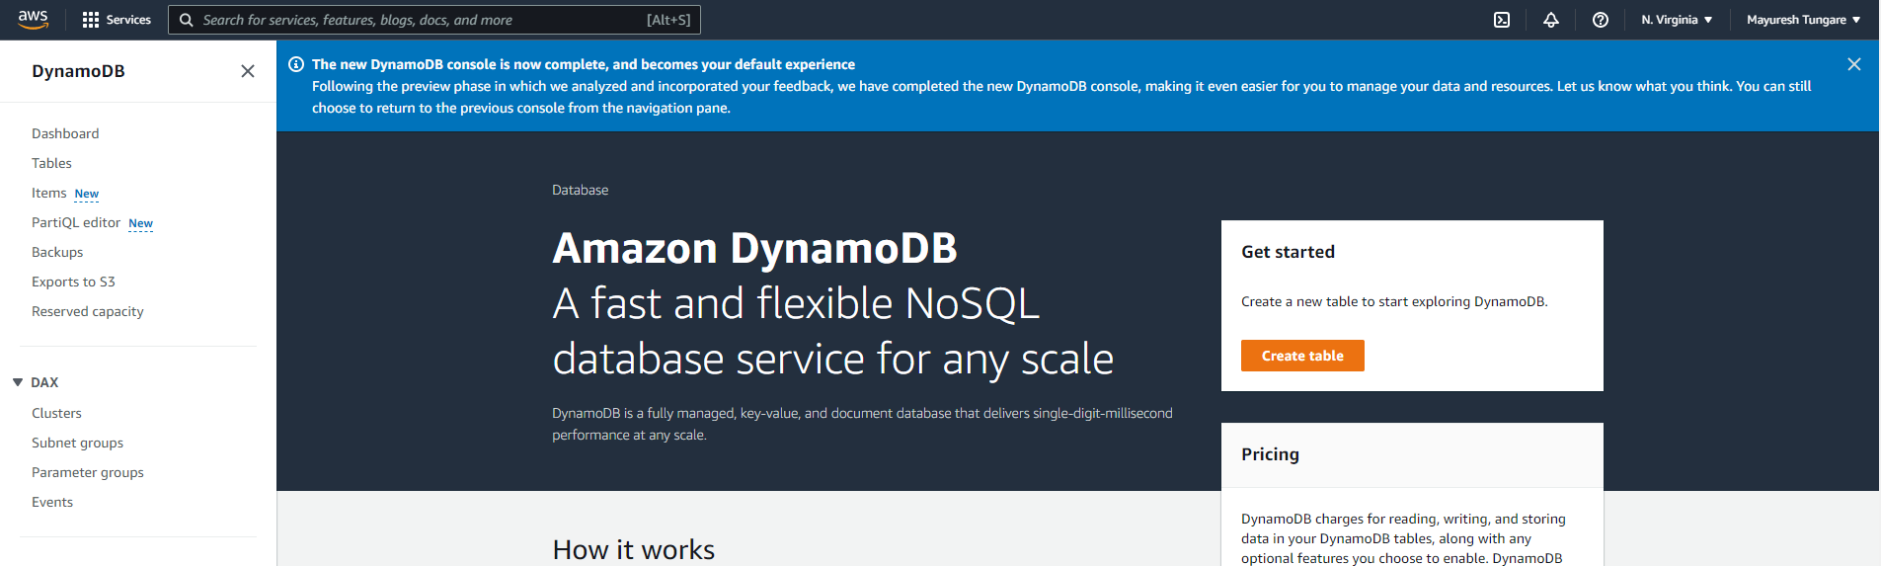

1. Enter details for the table as below – Table name, Partition key

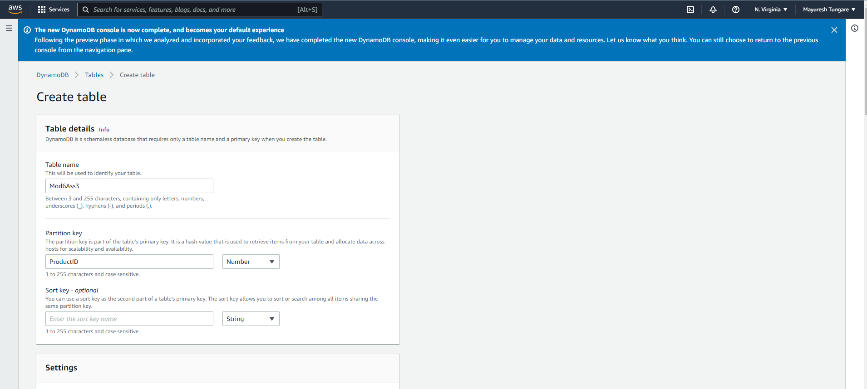

1. For table class, choose DynamoDB Standard and other values as shown below:

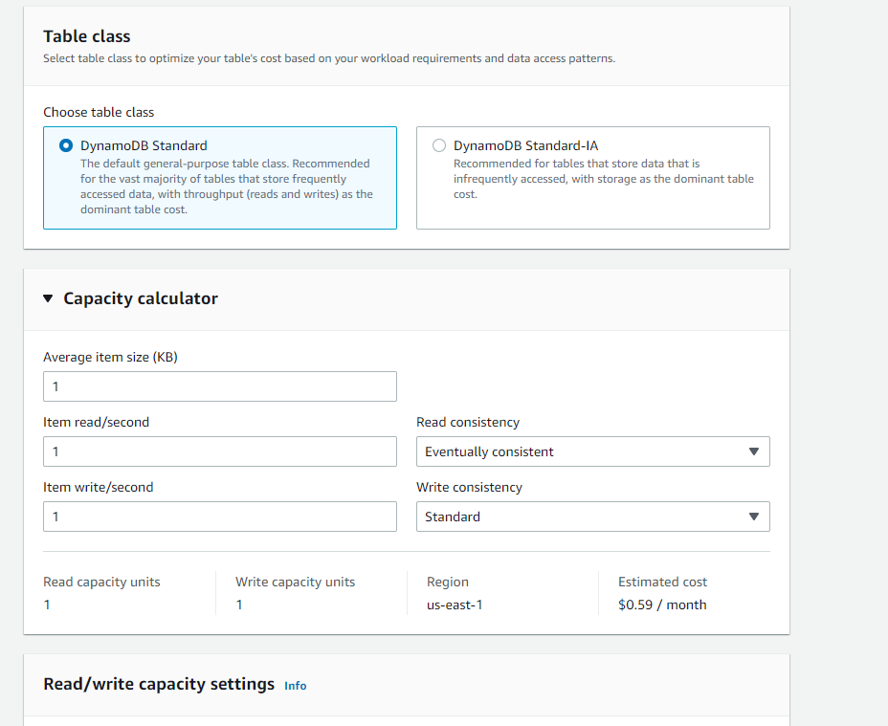

1. Set Read/write capacity as below:

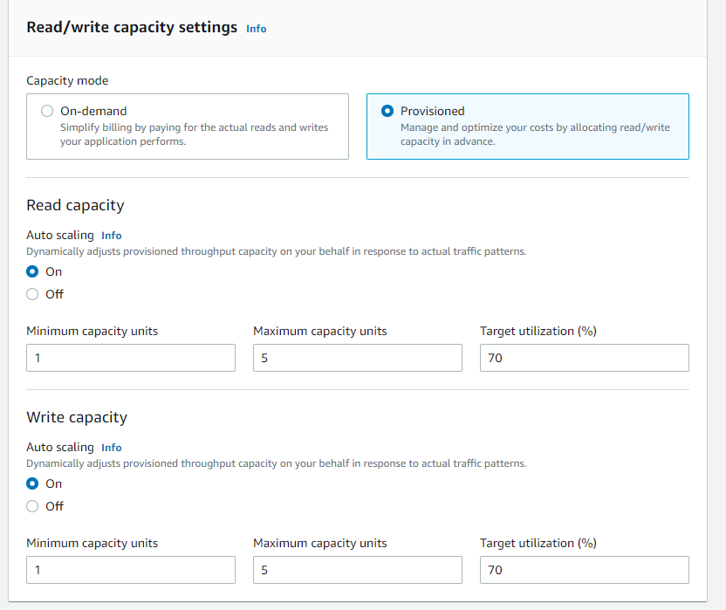

1. Choose encryption at rest by DynamoDB as below:

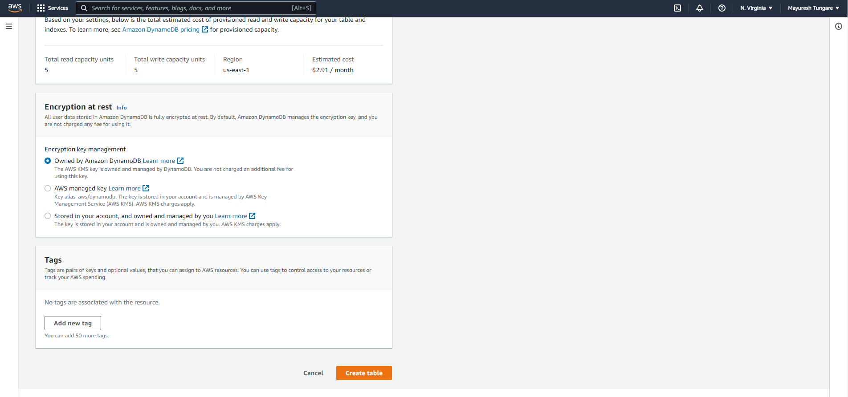

1. Click on create table and the database will be created as below:

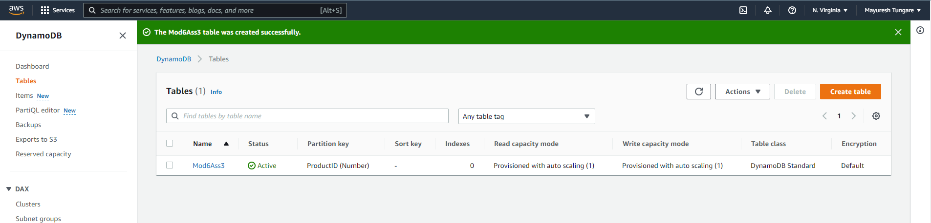

1. Now we can click on the Table name to see further details below. We can click on view items to add items:

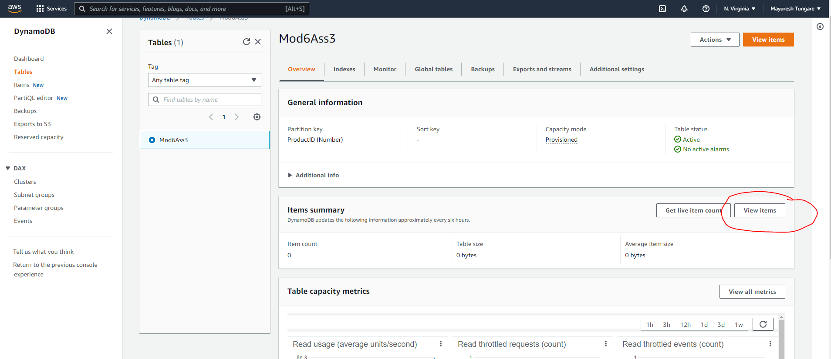

1. We add test data (3 items) as below:

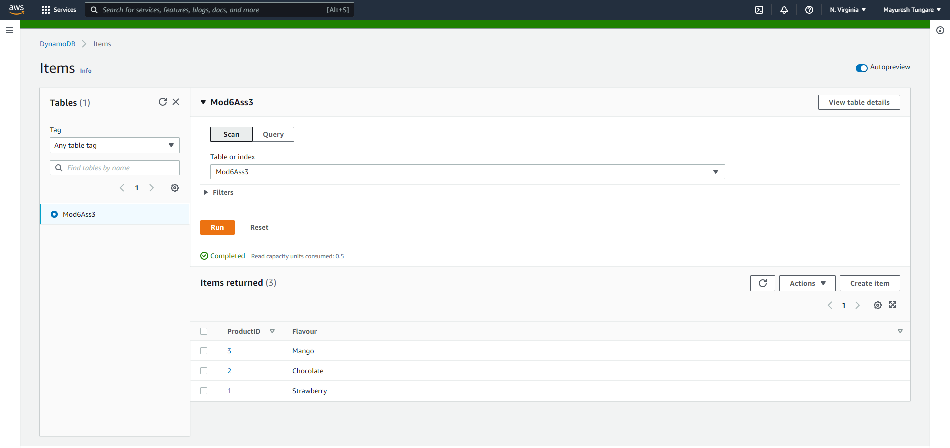

1. For backup, we choose the backup option as follows:

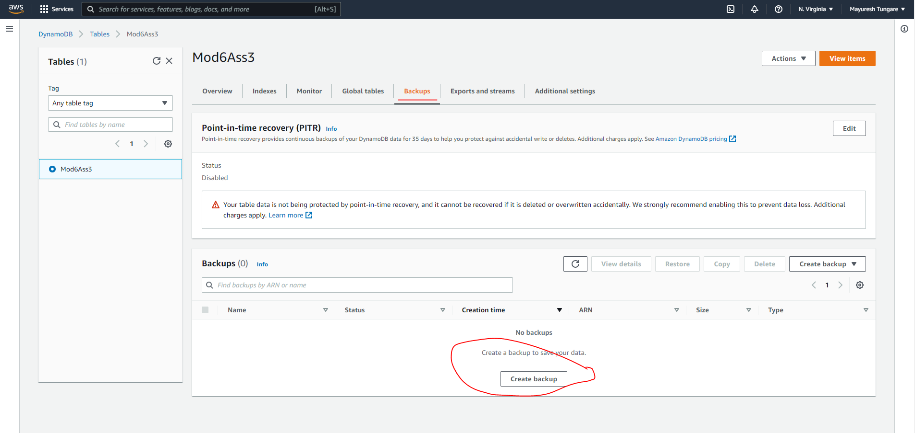

1. When creating a backup, enter appropriate name. backup will be created as shown below:

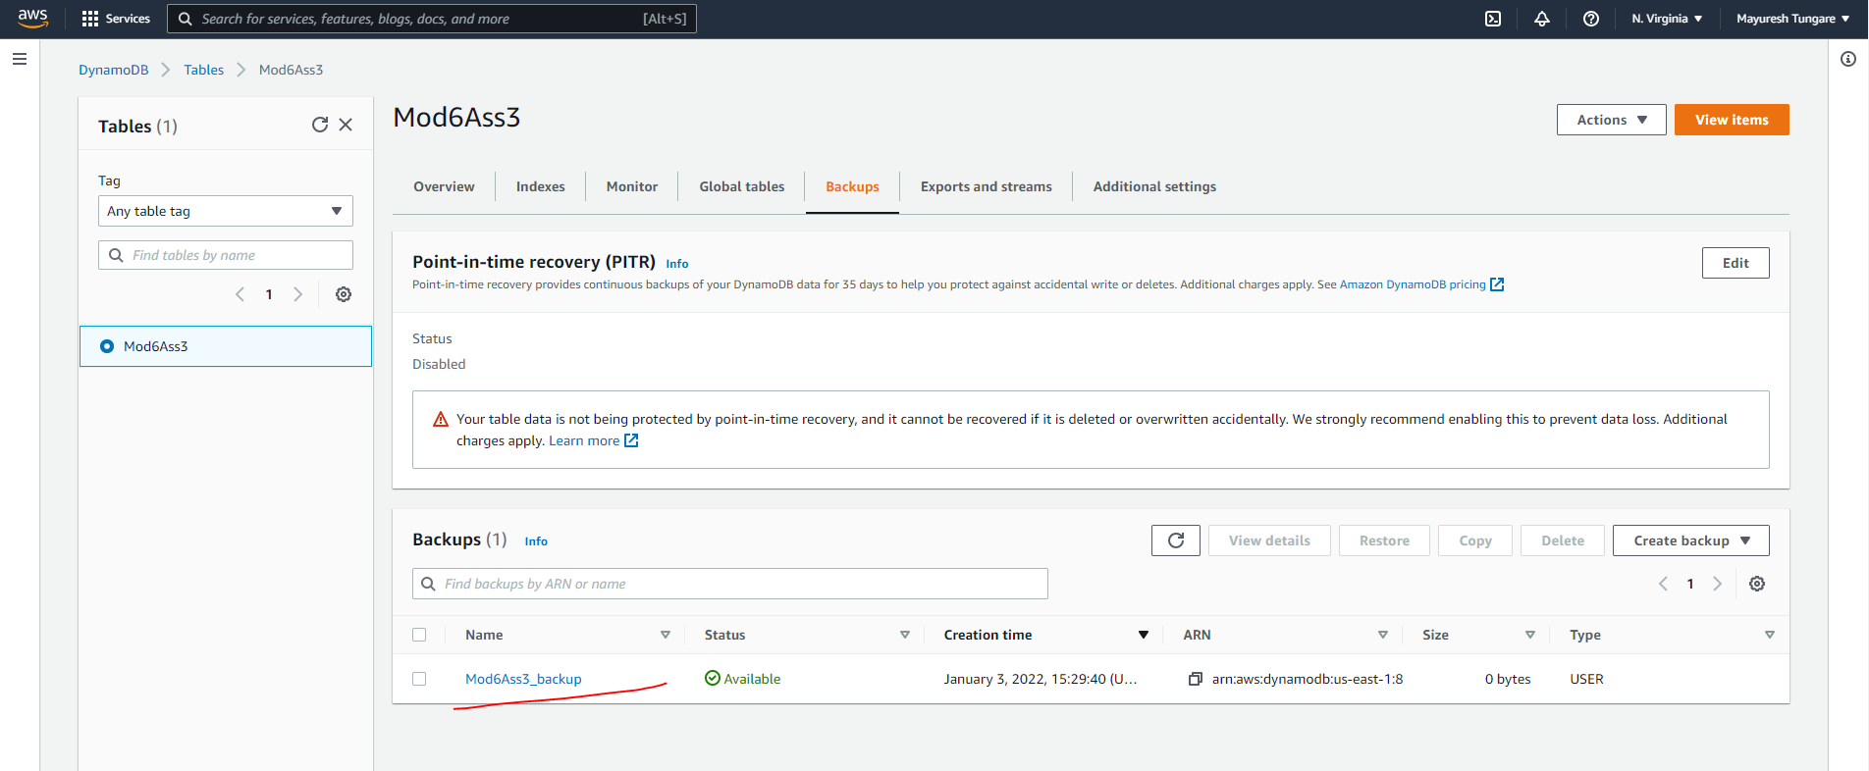

1. Now the final step is deleting the table. This can be by selecting the table record and clicking on delete.

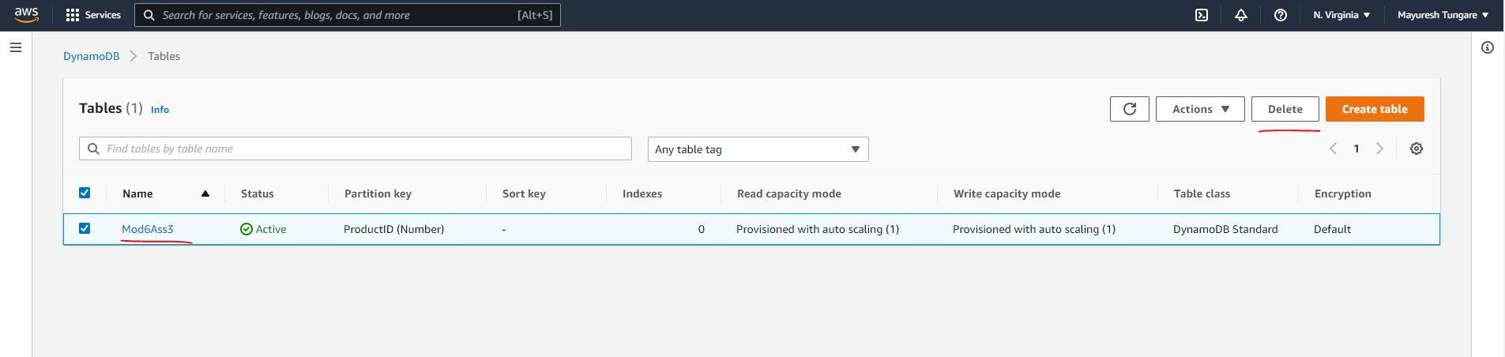

1. On clicking delete, we get the confirmation of the same as below:

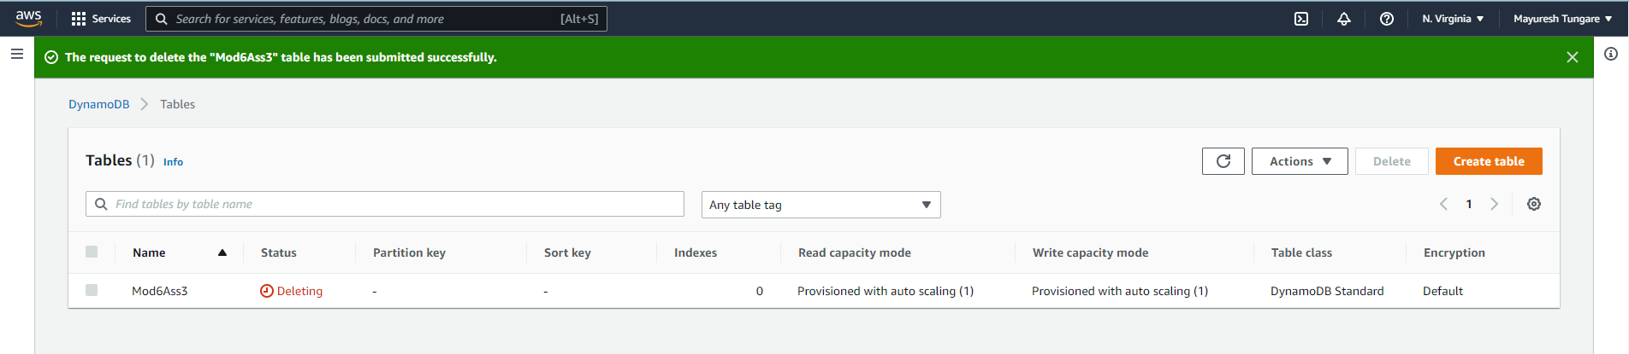

1. Thus the assignment is now complete.